**Xchecker Release Bulletin: 01/10/2018 (9 pages)**

New functionality for greater output control.

Overview.

Our latest Xchecker development allows you to take control of your criteria mapping, with;

* Quick and easy access to your TecDoc mappings
* Visibility of how your criteria will be published on TecDoc before you submit via TRC
* The ability to link your mappings as you create new criteria

This functionality has been released and made available to Xchecker Admins only. Should you wish to allow other users within your organisation access to this function, you will need to upgrade their user status to that of an Administrator. This level has been set because any changes made using this tool will result in that information being published on TecDoc, so accuracy is critical as any errors cannot be identified by Elcome.

We therefore recommend only experienced users with knowledge of TecDoc criteria use this feature.

In this bulletin we’ll familiarise you with the mapping screens and explain how you can make both Normal and Advanced links to your criteria. However, before you begin making any changes, it is important to understand the following rule set.

Understand the rule set.

Xchecker Criteria = XC TecDoc Criteria = TC

* A XC text box can only be mapped to a TC text box
* A XC drop down value can be mapped to both a TC drop down value and a TC text box
* XC can be mapped to multiple TC’s at once
* If a criteria needs to be Ignored it should still be mapped to a TC, it does not matter which because the functions are applied to mappings. If you want a criteria, or one of its values to be ignored then it still needs to be mapped to have that function applied to it.
* Should a XC need to be mapped to a different table than the normal TC tables, then it should be mapped as Advanced. The Advanced mapping function will automatically trigger a message to Elcome Support, who will assist you in mapping that criteria in the way you need.

Get to know the criteria mapping screen.

From your Xchecker home page go to:

**Manage> admin> apply criteria > criteria mapping**

The following grid will be displayed containing all your existing criteria.

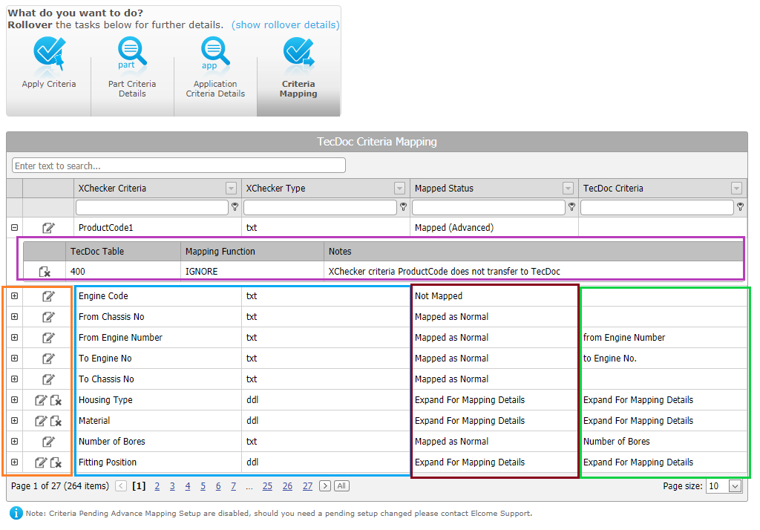

* The area marked in **orange** is where you can interact with your mappings, i.e. find out more detail , add or remove  mappings
* The area marked in **blue** contains the Xchecker criteria you have created and its type.
* The area marked in **red** advises you of your mapping status, which will be one of the following:
  + Not Mapped
  + Mapped as Normal
  + Mapped (Advanced)
  + Error - Mapped as Normal and Advanced
  + Error – Deleted values are still mapped
  + Pending Setup
  + Partially Mapped
  + Expand for Mapping Details
* The area marked in **green** shows the TecDoc criteria that your Xchecker criteriais mapped to. The only **exceptions** to this are for **Advanced** mapping – where the box will be blank and for criteria that are **drop-downs**, as they may be mapped to more than one TecDoc criteria.
* Finally, in the **purple box** we have an example of what the **detailed view** of an Advanced mapping criteria looks like. This view expands when you click 

Detailed Xchecker criteria view.

If you want to examine a drop-down Xchecker criteria in more detail, or view its values, simply select  to expand.

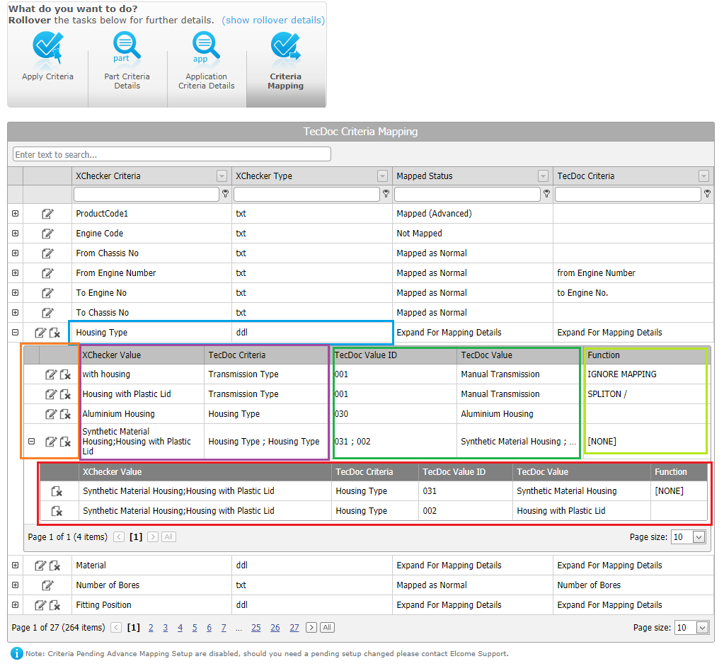

* The area marked in **blue** displays the Xchecker criteria
* The area marked in **orange** is where you can interact with your mappings, i.e. find out more detail , add , or remove mappings
* The area marked in **purple** contains all the values you have applied to that criteria and the TecDoc criteria they are mapped to
* The area marked in **green** shows the TecDoc values the criteria are mapped to, if any
* The area marked in **red** allows you to view whether a value has been mapped to multiple TecDoc criteria values
* The area marked in **light green** advises whether a function has been applied to them

Add a new link to your mapping.

Please note: the following process is for adding a link to your mapping only. It does not allow you to edit an existing link. If you need to make a change to an existing link, you should remove the old/incorrect mapping first by selecting  to delete, then add a new/correct link as follows.

For **Normal mapping**

Step 1 Select the Xchecker criteria you want to link by clicking on , which will open the following screen.

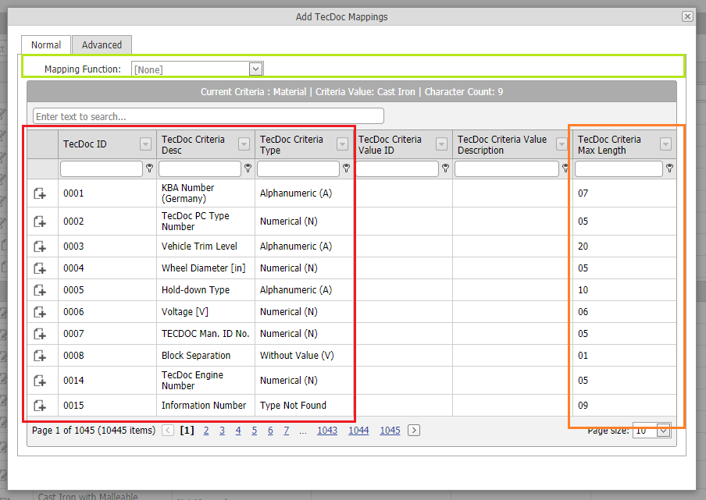

Step 2 The Mapping Function will be defaulted as [None] (marked in **light green**) and the corresponding TecDoc criteria will be displayed as a table (marked in **red**).

Step 3 Find the TecDoc criteria you wish to map to, then select by clicking the add button 

Step 4 Some TecDoc criteria’s have a maximum length, which are displayed in the last column (marked in **orange**). Should a XC value go over this, it will display as an error. If this occurs, you can either add a function **Split On** (see Step 5) or change the value to have fewer characters. If you cannot reduce the number of characters, or the problem persists, you should map using the **Advanced** tab

Step 5 If you require the **Mapping Function** to be changed, this should be done before you add the mapping and can be completed by selecting from the dropdown - currently limited to only **Split On** and **Ignore**

cid:image009.png@01D454B6.B5A138D0

cid:image007.png@01D454B6.AC7E33C0

Step 6 If you select **Ignore** for a Xchecker text box, this will be classed as an **Advanced** mapping (see below).

For **Advanced mapping**

When an Xchecker criteria requires more detailed mapping, such as text modules, country restrictions, MOT number conversions or you wish to add a function, this can be actioned in the **Advanced mapping** tab.

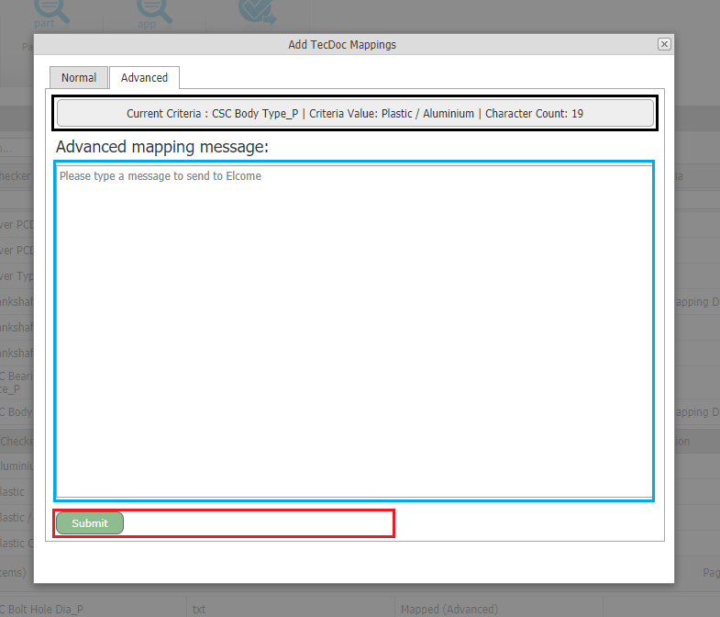

Step 1 Select the **Advanced** tab

Step 2 Add your message in the box provided (marked in **blue**)

Step 3 Select **Submit** to trigger an automatic message which will be sent to **Elcome Support** who will assist you in mapping the criteria in the way you require.

Elcome Screen Lock-out.

For maintenance purposes and to prevent overwriting issues, **Elcome** has retained the ability to **lock-out** the Criteria Mapping function in your Xchecker. In most instances, this will happen when you have asked **Elcome** to make changes to your mapping. When this occurs, the following message will be displayed, and the Criteria Mapping function will remain locked-out until any work has been completed.

If you think a lock-out has been activated in error, please contact **Elcome Support**.

A screenshot of a social media post

Description generated with very high confidence

**\*\*\*END\*\*\***